Ideation Phase
Define the Problem Statements

Date | 31 January 2025
Team ID | SWTID-2026-3627
Project Name | Smart Library Request Workflow In ServiceNow
Maximum Marks | 2 Marks

Customer Problem Statement:
Students, faculty members, and library staff need a seamless and efficient way to request, track, and manage library resources through a centralized platform, but the current process is often manual, fragmented, and lacks real-time visibility, leading to delays, unclear request statuses, and difficulty accessing materials when needed; from the customer’s perspective,
this creates frustration and reduces productivity, especially during time-sensitive academic work, while library staff face challenges in handling large volumes of requests and maintaining effective communication, ultimately resulting in operational inefficiencies and a poor user experience that highlights the need for a smart, automated library request workflow in ServiceNow.
Problem  Statement (PS) | I am  (Customer) | I’m trying to | But | Because | Which makes me feel
PS-1 | A library user (student | Request books, journals | The current request process is manual | There is no automated workflow | Frustrated due to delays, lack of visibility, and inefficiency

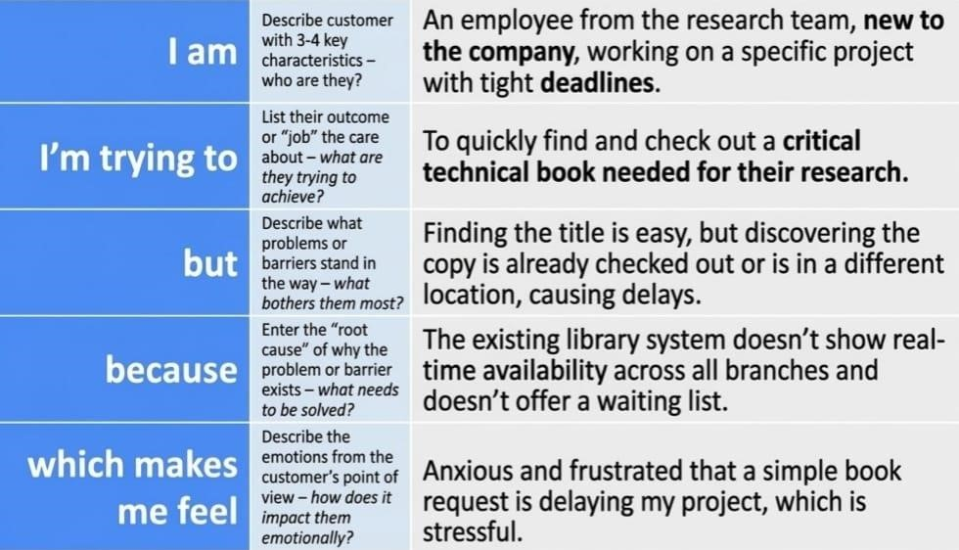
Reference: https://www.servicenow.com/community/developer-forum/service-catalog-requestworkflow/td-p/3225248?utm_source=chatgpt.com
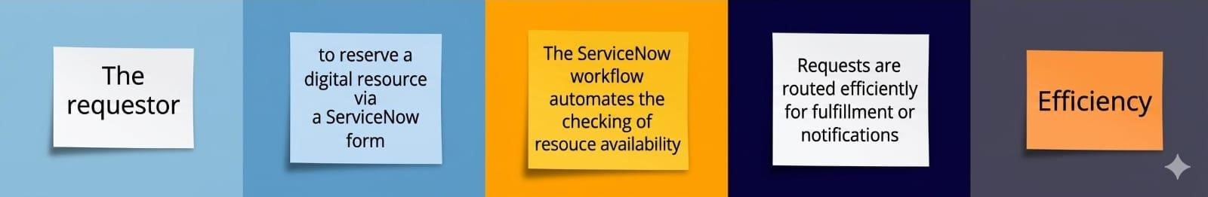
PS-2 | A librarian or admin managing library requests | Process and  fulfill multiple resource requests efficiently | Requests come through different channels | There is no unified  platform like ServiceNow to automate and manage workflows | Overwhelmed and prone to errors or missed requests

